Udacity Robotics Nanodegree Term 2

Robotic Inference

Robert Aleck, 18th May 2019

# Abstract

In this paper, the author outlines an approach to training the well-known “GoogLeNet” network for image classification on a simple set of data with 3 classes, provided by Udacity, achieving greater than 75% accuracy. Further work was then carried out to capture a new 3-class dataset, and to train a model to differentiate a salt grinder, a pepper grinder, and a sugar pourer. This resultant model achieved accuracy no better than chance when trained.

# Introduction

Object Classification is a well known but ongoing challenge in computer science, aimed at identifying the content of an image. Using NVIDIA’s DIGITS workflow, this project aimed to demonstrate the development of a classification model:

* Initially for a provided set of labelled images representing candy boxes, bottles, and an empty conveyor, and
* Later, for a set of images representing a salt-grinder, pepper grinder, and sugar pourer.

Ultimately, a model trained using these datasets could be deployed to the real world in situations such as object selection or sorting.

# Data Acquisition

## Provided dataset

On the provided Udacity workspace, the /data/P1_data folder contains some 10,094 images captured by an overhead camera of bottles and candy wrappers passing under the camera on a conveyor belt, including images captured with no object in the camera’s field of vision. As objects pass under the camera, it is intended that a classifier would identify the object type, and trigger an action (e.g. a swing arm further down the belt) to sort/select items.

## Additional Dataset

Approximately 1,000 photos were taken using an iPhone XS of three items commonly found in cafes and restaurants – a salt grinder, a pepper grinder, and a sugar pourer. The samples were spread roughly evenly across each set. A recognised limitation is that the objects are all of a single design, although care was taken to ensure that images were captured from a variety of angles and orientations. The images were then rescaled from approximately 4MP to 256x256 pixels (colour), and labelled. Approximately 10% of images were removed in to a test set.

# Training

Initial training focused on achieving a 75% accuracy on the provided dataset. Various models were trialled – including later versions of the Inception/GoogLeNet model to attempt to increase accuracy and response time.

|  |  |  |  |
| --- | --- | --- | --- |
| Model | optimizer | Training time | Accuracy |
| AlexNet | SGD | 18 minutes | Approx. 68.55%1 |
| GoogLeNet (inception v1) | ADAM | Approx. 20 minutes | 75.41% |
| GoogLeNet (inception v1) | SGD | Approx. 20 minutes | 74.11% |
| Inception v32 | SGD | 90 minutes | 30.43% |
| Inception v42 | SGD | 130 minutes | 33.98% |

1. The AlexNet models would not validate using the built in “evaluate” command; this validation was performed manually on a subset of the full test set.
2. Inception v3 and v4 were modified from the samples available at <https://github.com/SnailTyan/caffe-model-zoo>

The models tended to converge relatively quickly, with little improvement in validation loss beyond 2 or 3 epochs: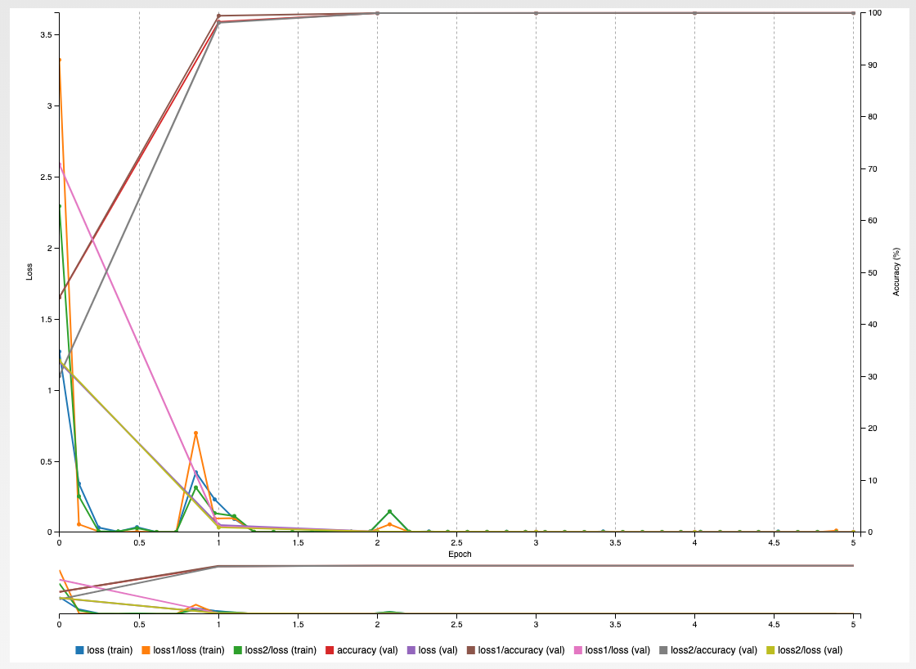

Having settled on GoogLeNet/Inception v1 with ADAM, this was then retrained on the newly acquired dataset of salt grinders, pepper grinders, and sugar pourers. Training times were roughly the same.

# Results

## Acquired dataset

Using the test data set separated during data preparation, an accuracy of 35.58% was achieved; this is not materially better than pure chance. Indeed, looking at the probabilities assigned to each class for each test object, we can see that they all hover around the 1/3 mark:

|  |  |  |  |  |  |  |  |  |
| --- | --- | --- | --- | --- | --- | --- | --- | --- |
| image | label | 1 | 1 likelihood | 2 | 2 likelihood | 3 | 3 likelihood | correct? |
| 1 | pepper | **pepper** | **35.29%** | **sugar** | **32.91%** | **salt** | **31.80%** | Yes |
| 2 | pepper | **pepper** | **35.26%** | **sugar** | **32.94%** | **salt** | **31.81%** | Yes |
| 3 | pepper | **pepper** | **35.26%** | **sugar** | **32.93%** | **salt** | **31.81%** | Yes |
| 4 | pepper | **pepper** | **35.19%** | **sugar** | **32.98%** | **salt** | **31.83%** | Yes |
| 5 | salt | **pepper** | **35.21%** | **sugar** | **32.95%** | **salt** | **31.84%** | No |
| 6 | salt | **pepper** | **35.14%** | **sugar** | **33.02%** | **salt** | **31.84%** | No |
| 7 | salt | **pepper** | **35.21%** | **sugar** | **32.97%** | **salt** | **31.83%** | No |
| 8 | salt | **pepper** | **35.23%** | **sugar** | **32.95%** | **salt** | **31.82%** | No |
| 9 | sugar | **pepper** | **35.08%** | **sugar** | **33.07%** | **salt** | **31.85%** | No |
| 10 | sugar | **pepper** | **35.15%** | **sugar** | **33.01%** | **salt** | **31.84%** | No |

# Discussion

## Provided dataset

The original GoogLeNet (also called “Inception v1”) model achieved best in class [1] image classification across 150,000 images of 1,000 classes [2] at ILSVRC2014. More recent versions of the GoogLeNet/Inception have been released offering greater speed and higher accuracy:

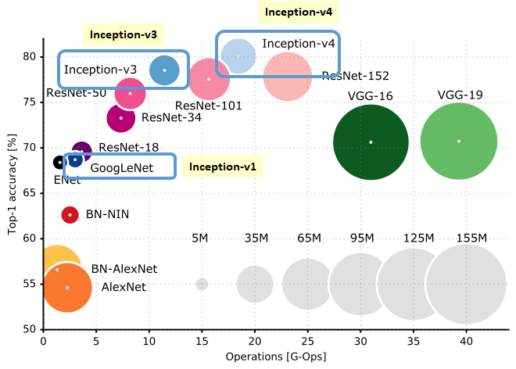

Figure Top-1 Accuracy against Number of Operations (from [3])

Our results indicate that, while the more complex Inception v3 and v4 models may well provide significant performance and accuracy gains for large datasets with a significant number of classes, their complexity leads (and hence the number of trained variables) to significantly increased training time, and even when adjusted to account for the reduced number of classes, they appear to do no better than chance.

## Acquired dataset

The *provided* dataset is of high quality: images are captured from a static viewpoint, are well lit, and relatively clear. Examination of the *acquired* dataset shows that many images are blurred, and the number of different angles and orientations means that although there is a large number of images per class, there are relatively few images of the object from highly adjacent viewing angles (e.g. there are only 30-40 photos of the salt shaker grinder from the top). This appears to have massively reduced the ability of the model to train effectively – in short, the training was unsuccessful.

# Future Work

Future work should include:

* Capturing higher quality samples of the salt grinder, pepper grinder, and sugar pourer. Specifically, future datasets should include a larger number of images from across the range of capture angles and orientations.
* If it is desired that the system can differentiate other models of salt grinder, pepper grinders, or sugar pourer, the captured images might be augmented with existing images from well known datasets, such as ImageNet, or by searching sources such as flickr for images.

# References

|  |  |
| --- | --- |
| [1] | ImageNet, “Results of ILSVRC2014,” 2014. [Online]. Available: http://image-net.org/challenges/LSVRC/2014/results. [Accessed 18 05 2018]. |
| [2] | IMAGENET, “Imagenet Large Scale Visual Recognition Challenge 2014 (ILSVRC2014),” 2014. [Online]. Available: http://www.image-net.org/challenges/LSVRC/2014/. [Accessed 18 05 2019]. |
| [3] | S.-H. Tsang, “Review: Inception-v4 — Evolved From GoogLeNet, Merged with ResNet Idea (Image Classification),” 27 09 2018. [Online]. Available: https://towardsdatascience.com/review-inception-v4-evolved-from-googlenet-merged-with-resnet-idea-image-classification-5e8c339d18bc. [Accessed 18 02 2019]. |